📝 Notes
Apr 24, 2026

Contained Animal Management System | SolutionLab 2
Invited Christian Ruiz Francisco Perez Tyler Morton Raul Montenegro Claudiu Constantin wyldsolconsulting@gmail.com
Attachments Contained Animal Management System | SolutionLab 2
Meeting records Transcript Recording

Summary
Meeting discussions focused on defining actor roles, media workflow strategies, and prioritizing mobile-first design system development.
Defining Roles and Workflow
Defined 3 core actors including rancher, owner, and partner roles while clarifying media upload requirements. Team established that in-app media capture is preferred for tagging capabilities.
Technical Strategy and Design
Adoption of a mobile-first design approach prioritizes native camera features for field use. Future iterations will include automated billing systems and performance monitoring.
Feature Set and Scope
Expanded the minimum viable product feature set to include basic analytics, lineage management, and non-credit card payment options. The decision to adopt a mobile-first design was finalized.

Rate this Summary: Helpful or Not Helpful

Decisions
We've updated the Decisions section using your feedback.
Let us know what you think: Helpful or Not Helpful

ALIGNED
- Offline media upload strategy Retry queue mechanism selected for offline media uploads in MVP over building full offline support.
- Invoicing integration strategy Self-contained invoicing functionality selected for MVP, excluding QuickBooks integration.
- Mobile-first development approach Mobile-first development approach adopted for core features, including camera access and push notifications.
- MVP analytics feature inclusion Basic analytics and overview functionality included in MVP scope.
- Partner media access restrictions Partner access to media restricted to read-only interactions for MVP.

Next steps
- [WyldSol] Send Logo: Provide SVG files for the logo.
- [Christian Ruiz, Francisco Perez] Investigate Upload: Research user experience, time to market impact of upload queue functionality.
- [WyldSol] Check Invoicing: Determine preference for invoicing system integration versus self-contained app functionality.
- [WyldSol] Review Bull Data: Investigate fields required for manual bull performance data input.
- [WyldSol] Follow Up API: Contact API representative on Monday; update Basecamp with API website information.
- [WyldSol] Share Screenshots: Save and send screenshots of media tagging UI concepts.
- [WyldSol] Provide API Fields: Give Christian Ruiz the required list of API fields matched to public data.
- [Francisco Perez] Schedule Meetings: Coordinate and book calendar invites for the next 2 design reviews and Workshop 3.

Details
Did the screenshots in this section make your notes better or worse?
- Logo File Requirement: The primary discussion began with a request for the logo's SVG files, which were identified as the only missing asset needed to start working on the designs. WyldSol confirmed they possessed the files and would send them, noting this commitment (00:00:00).
- Review of Actor Mapping and Use Cases: The team reviewed the existing actor mapping and the general use cases that had been pre-mapped as homework, since the actor mapping was completed ahead of schedule in the previous session. The three main actors identified are the rancher/trainer, the bull owner, and the partner (00:01:04).
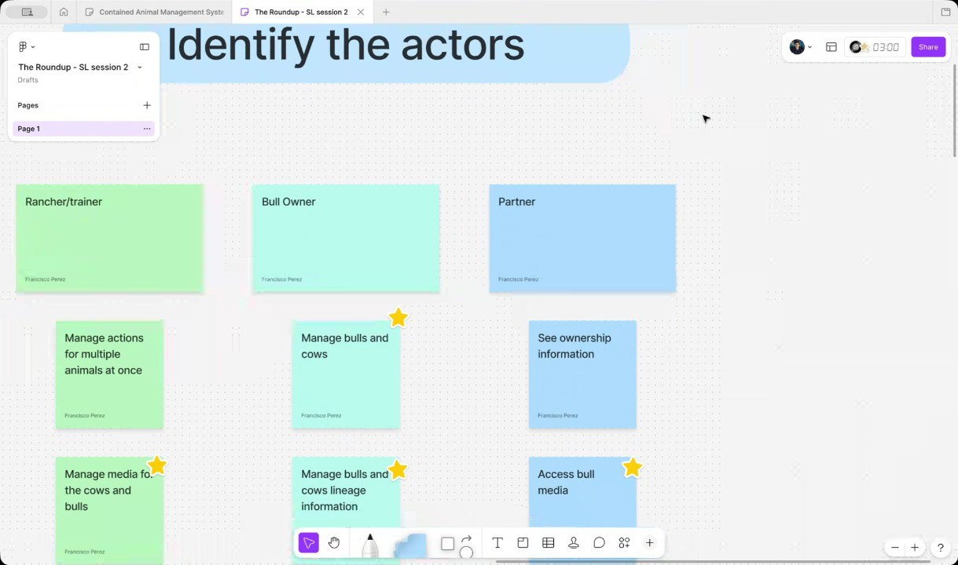
- Administrative and E-commerce Actors: WyldSol noted the administrative tasks related to e-commerce, such as collecting data, enabling purchased features, and potential storage tiering, as activities the team would handle that may warrant an additional actor (00:02:10). These tasks are expected to be part of later iterations after the Minimum Viable Product (MVP) (00:03:28).
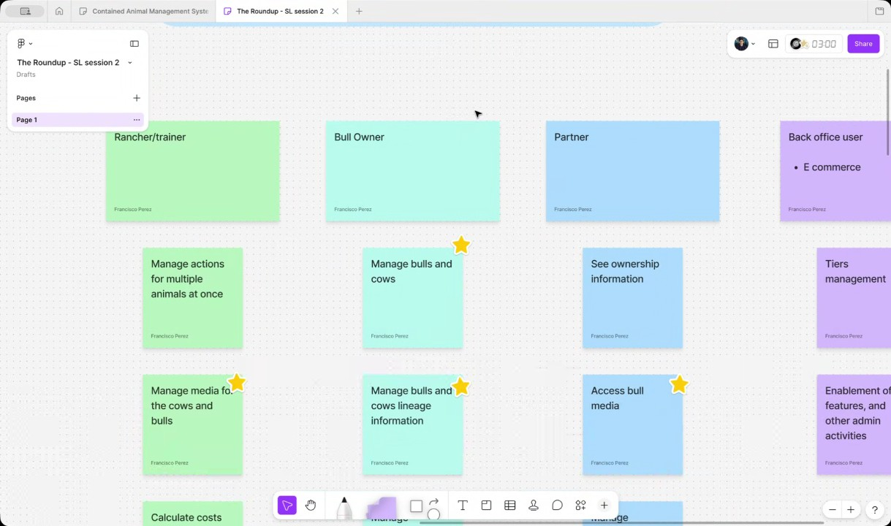
- Rancher/Trainer and Bull Owner Overlap: It was confirmed that rancher/trainers often overlap with bull owners, as they may manage their own bulls and cows in addition to those boarded by other owners (00:03:28). The most common scenario involves both the rancher/trainer also being an owner, and managing bulls sent to their ranch by other owners (00:04:30).
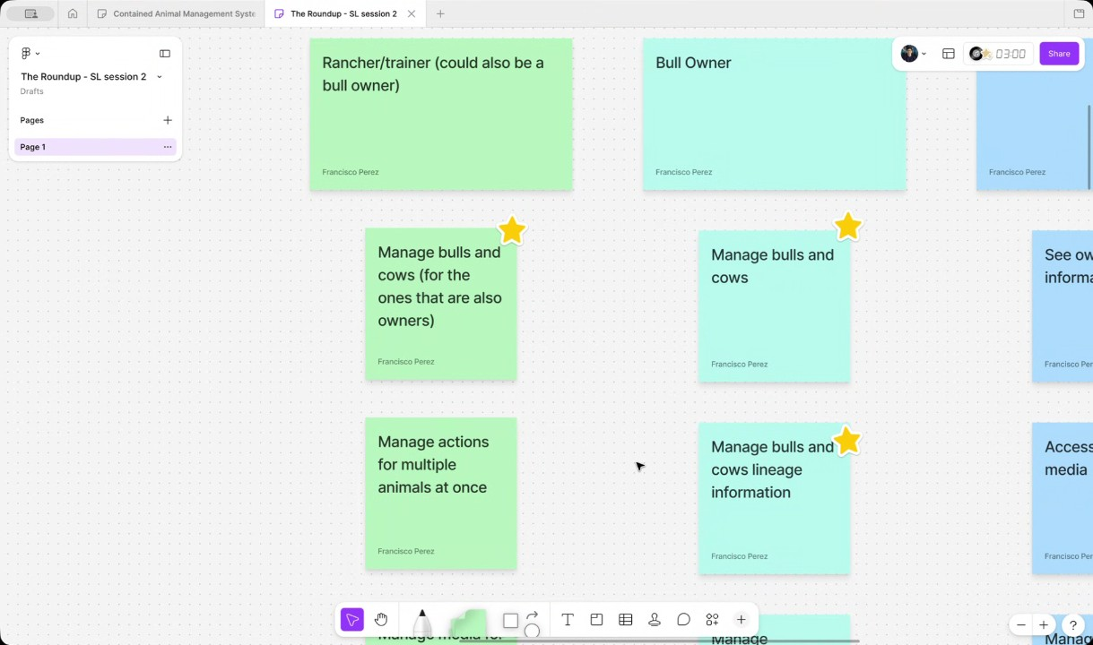
- Management of Multiple Animals and Post-MVP Features: The management of actions for multiple animals at once, such as transportation and feeding, was confirmed as an activity intended for post-MVP implementation. These activities relate to the inventory management for both individual and groups of animals (00:05:35).
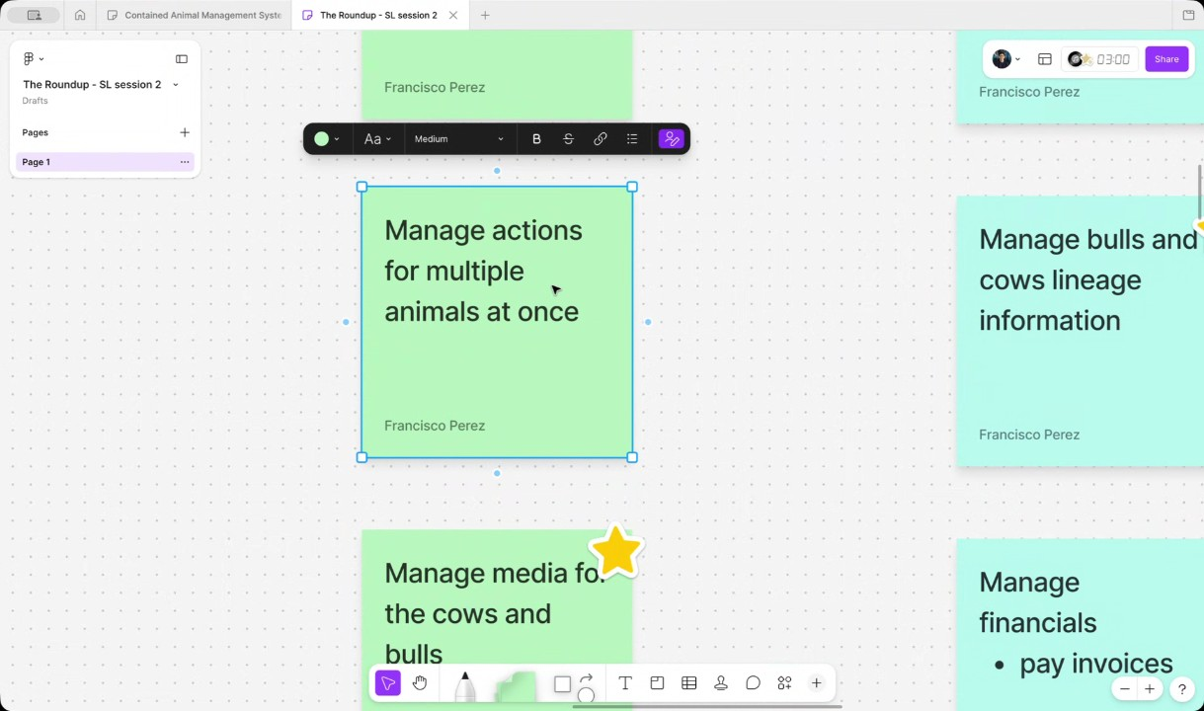
- Workflow for Managing Bull Media (MVP Feature): Managing media for bulls and cows is a key MVP feature that requires clarification on the expected user workflow. The discussion centered on whether users would take pictures and videos directly within the application for automatic content organization or upload existing media, with the preferred workflow being through the app to support automatic tagging (00:06:49).
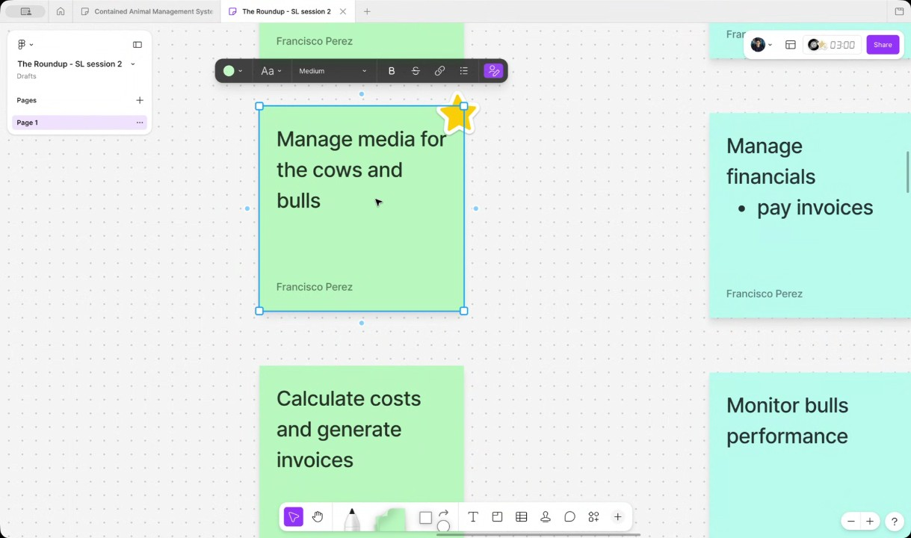
- Media Upload Technical Considerations: It was determined that the media management system must support both in-app capture and the uploading of existing media files, including large files, as well as external links like YouTube and Instagram (00:07:50). Given that media is often captured in environments with limited Wi-Fi, the team discussed implementing a "keep trying until you have a connection" queue for uploads, rather than a full offline-then-sync model, which Christian Ruiz will investigate (00:08:51).
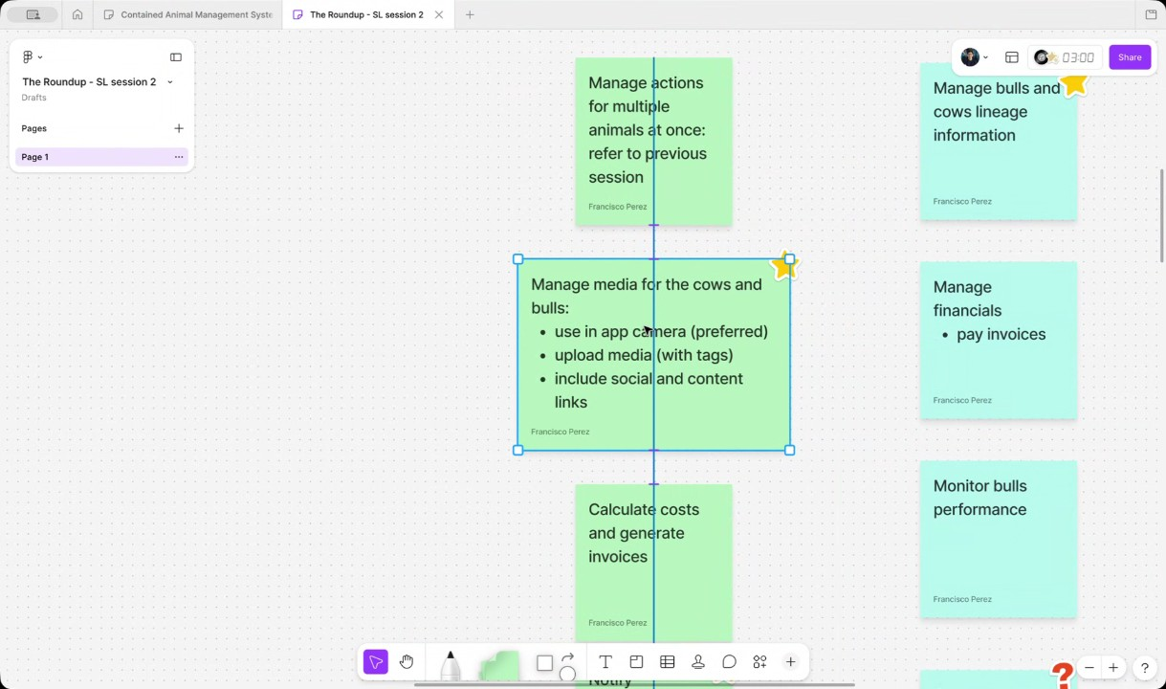
- Invoice and Billing System Approach: The long-term goal is to calculate costs and generate invoices, but the team will not build a full billing system. WyldSol will investigate if using QuickBooks is still necessary for invoicing or if a self-contained in-app system would be preferred, which is planned for after the MVP (00:12:08).
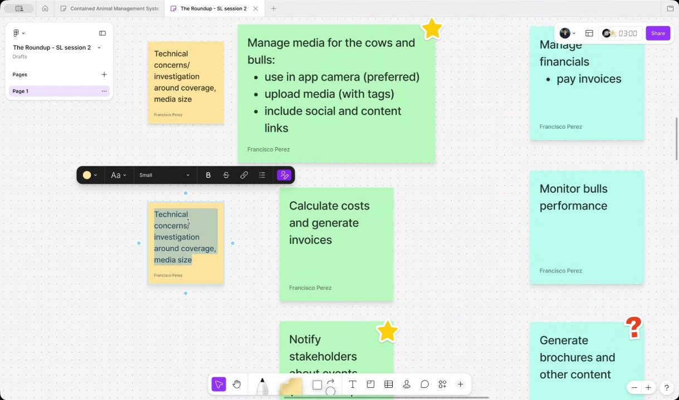
- Notification Channel Strategy: Notifying stakeholders (primarily for new media in the MVP) requires considering push notifications alongside email and text messaging, as some recipients may not be active app users (00:13:14). It was agreed that targeting a mobile application design is logical to leverage native features like push notifications and the camera (00:14:23).
- Mobile-First Design Decision: The team decided to adopt a mobile-first design approach, prioritizing the mobile experience for features best suited for phones, like media upload and native camera functionality (00:15:40). This approach simplifies the complex data uploading process for users who are typically in the field (00:16:47).
- Rancher/Trainer Feature Set Updates: The feature set for the rancher/trainer was expanded to include managing lineage information and collecting payments, particularly via non-credit card options like Automated Clearing House (ACH) transfers, due to the high fees associated with large transactions (00:20:31). It was also requested that a basic analytics or overview section be included in the MVP, summarizing information like the number of bulls and ownership details (00:21:40).
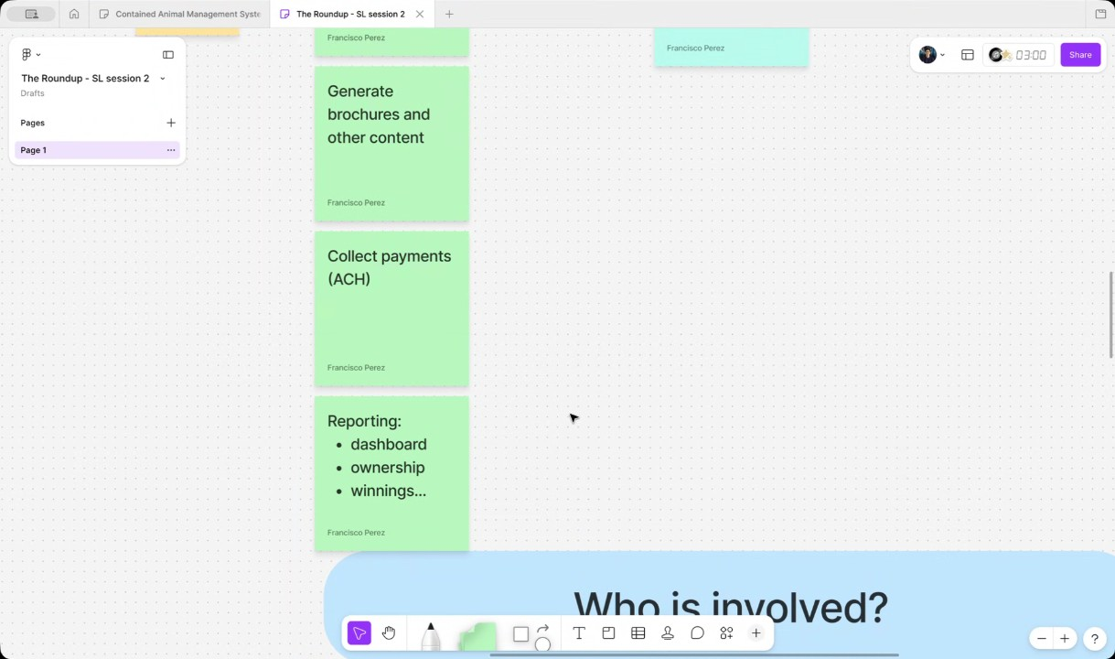
- Bull Owner Use Cases: Key use cases for the bull owner include managing bulls, cows, and lineage, paying invoices, and collecting payments from partners (00:22:35). Monitoring bull performance is planned for a later phase, likely after integration with a performance API currently being developed (00:23:28).
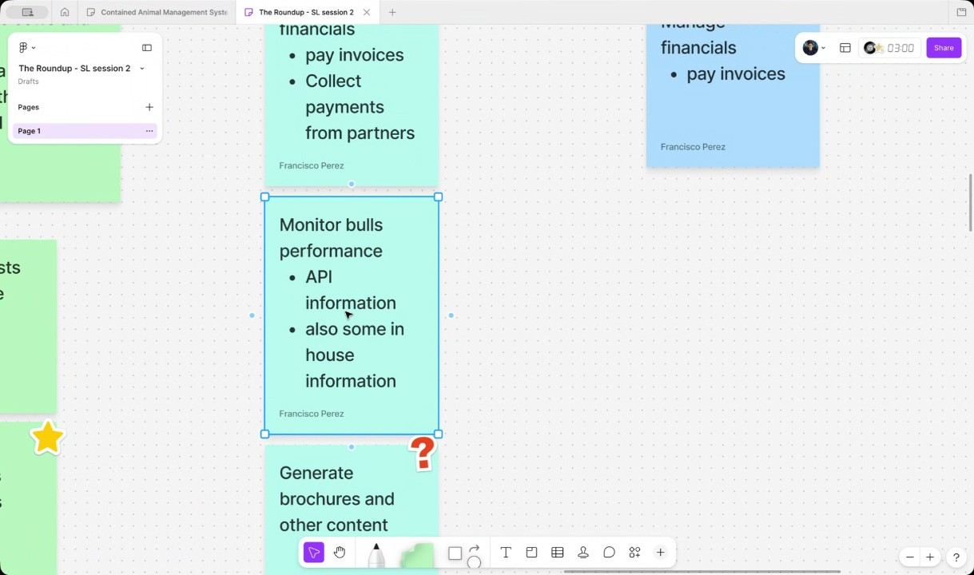
- Partner Use Cases and Media Interaction: The partner's primary use is consulting information, which means they require read-only access to a bull's profile, including ownership details, lineage, and API results (00:25:55). Partners also need access to bull media and the ability to add comments to both the media and the bull's profile, maintaining a running thread of comments (00:27:10).
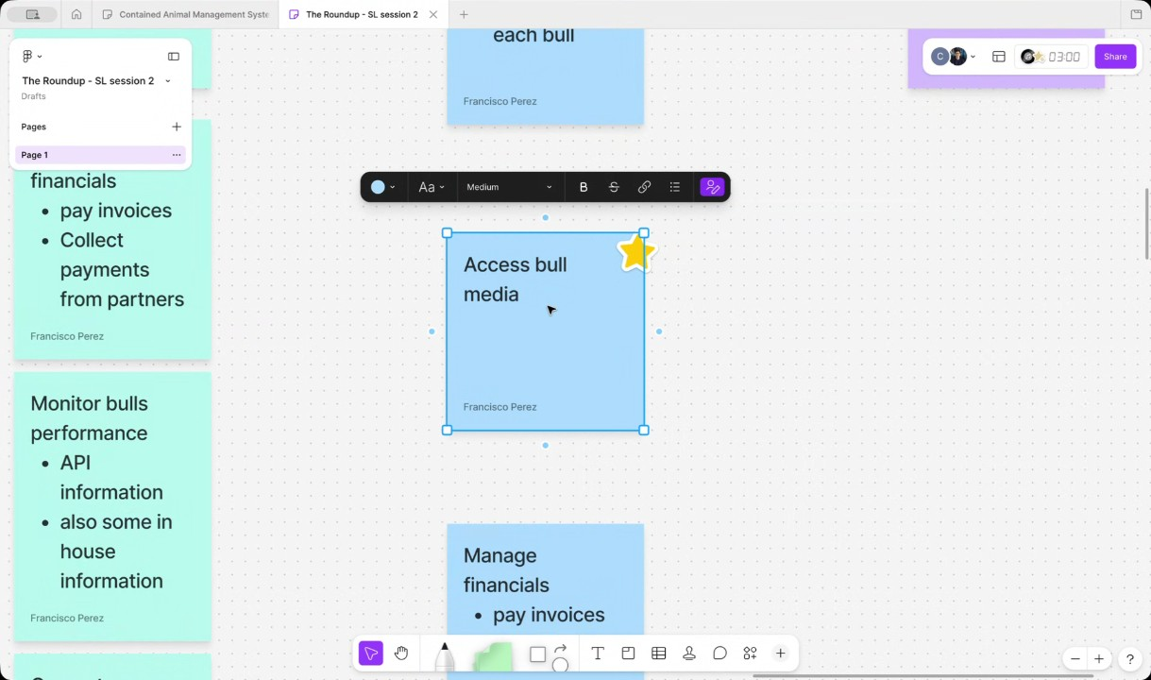
- Partner Payment and Reporting: Partners will get paid based on winnings determined by their percentage of ownership, a process that is currently manual and ideally should be automated in the future (00:28:15). Analytics were also added as a necessary feature for the partner, similar to the rancher/trainer, for reporting (00:29:24).
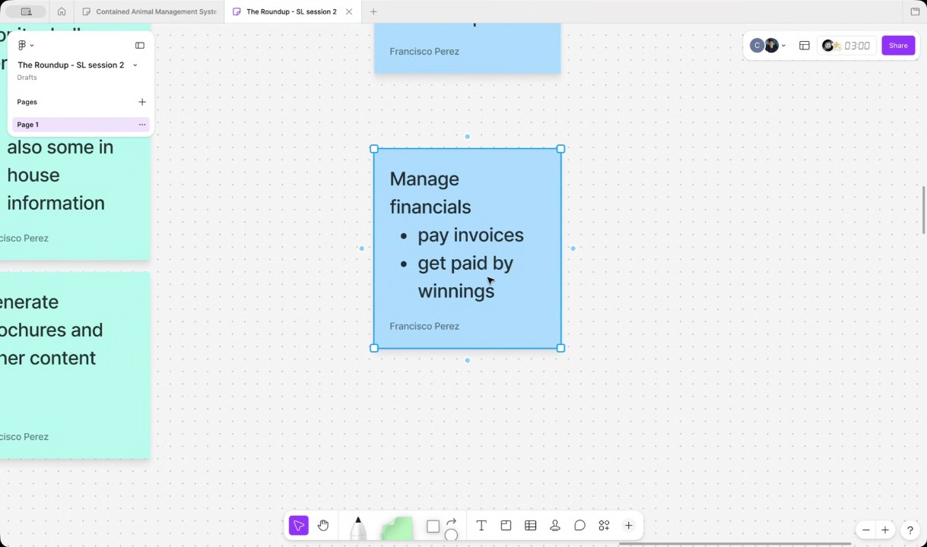
- Defining Design Priorities and Next Steps: The focus for design remains primarily on the rancher, bull owner, and partner, who are considered homogeneous, direct users of the application (00:30:45). Christian Ruiz will investigate the API and data sources further, and WyldSol will provide screenshots and specific field requirements for tagging and media concepts (00:31:38).
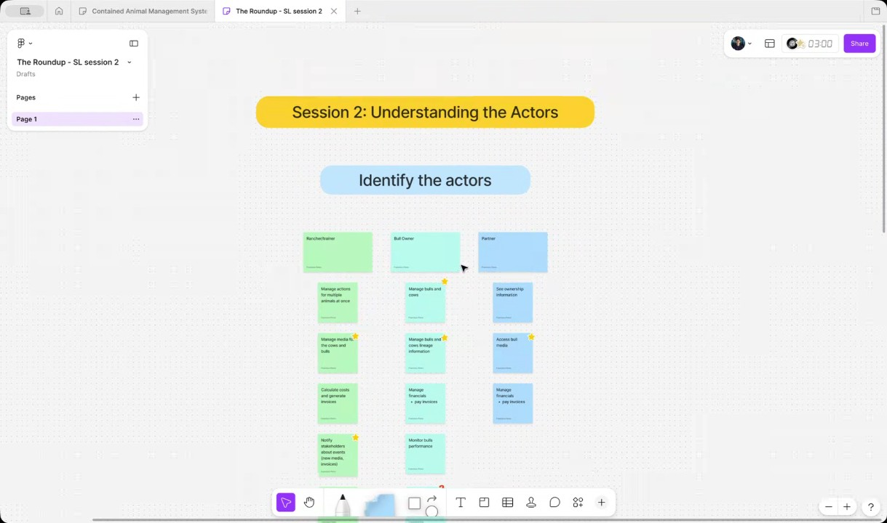
- Scheduling Design Reviews and Next Workshop: The team scheduled the first design review for the following Tuesday at 8:00 AM Mountain time, expecting it to last about an hour (00:34:59). A third workshop was tentatively scheduled for the following Wednesday before noon, with a second design review targeted for Friday at 10:30 AM or later .

You should review Gemini's notes to make sure they're accurate. Get tips and learn how Gemini takes notes
How is the quality of these specific notes? Take a short survey to let us know your feedback, including how helpful the notes were for your needs.

📖 Transcript
Apr 24, 2026

Contained Animal Management System | SolutionLab 2 - Transcript

00:00:00

Francisco Perez: uh the documents and elements you you sent. Uh but he asked me to request if possible if you had the SVG
WyldSol: Mhm.
Francisco Perez: files for the logo.
WyldSol: Yes, I do. Shoot, I forgot to send that.
Francisco Perez: Okay.
WyldSol: Yep, I'll get them over. I'll take a
Francisco Perez: Yep.
WyldSol: note.
Francisco Perez: I think that's all he he was missing for starting to work on the designs uh with the actual uh assets.
WyldSol: Okay.
Francisco Perez: Right. So, yep. I think that's the only the only thing he wanted.
WyldSol: Okay.
Francisco Perez: Okay. All right. Let's get started with this meeting then. Um so let me share my screen real quick and let's take a look at what we're going to be doing today. So as part of the previous session, we mapped a lot of um a lot of actors, right? So uh the actors we mapped, we looked at them kind of like as an overview. If you remember, you gave us information about about them, but you also uploaded some really useful documents which actually uh are helping us do this a lot faster, right?

00:01:04

Francisco Perez: That's normally what we would map in this second session, but you already have the map. So, what what we did today was we did some homework just mapping general uh use cases of these actors, which is normally what we tend to focus on on this specific workshop. So what I want to do today is simply go through them and review them maybe uh answer get get answers for some questions we may have about them and uh let us know what which are the ones that are most fitting for the MVP if we coincide with the ones that we we selected or if we are missing any use case any potential use case or anything also let us know right so let's get started with this um these are the three main actors that we that we have right the
WyldSol: Okay.
Francisco Perez: rancher or trainer the bull owner and the partner. Right? So my first question here is uh what do you think there are going to be any administrative tasks that maybe is going to be performed by you or someone in your team that we should include kind of as another actor here or do you think that's not needed?

00:02:10

WyldSol: Um, well, we will have the ecommerce. So, I don't know if we need to put that on here or not, but that would be the only thing that my team would
Francisco Perez: Okay.
WyldSol: do to um
Francisco Perez: And the e-commerce is the
WyldSol: because they'll come to the website and well,
Francisco Perez: what?
WyldSol: they'll either come to the website. Well, I guess we haven't figured that out. They'll either come to the website and buy it or they'll go to the app and buy it.
Francisco Perez: Oh, okay. Okay.
WyldSol: Probably the website.
Francisco Perez: Right. Okay.
WyldSol: So,
Francisco Perez: I'm going
WyldSol: that'll be something that we'll do. Um, so I haven't really thought through that, but I'm sure it's collection of the data.
Francisco Perez: to
WyldSol: Um, maybe giving a tier depending on because there's a lot of storage with that media. So I imagine that some kind of tier process will take place um later for storage
Francisco Perez: Okay.
WyldSol: maybe
Francisco Perez: Yeah. And I I guess uh there's also going to be I don't know if if if there's going to be any other activity related to enabling what the bull owner part of rancher are going to be doing here.

00:03:28

Francisco Perez: So
WyldSol: later there probably will be. Yeah.
Francisco Perez: maybe
WyldSol: So if they come in and purchase um other features in the app, there'll probably be enablement of those features like the um um the brochure and stuff that we talked about
Francisco Perez: okay.
WyldSol: having the AI piece. So yeah, that'll probably be that.
Francisco Perez: Okay. Yeah, I'm just going to map them here right now just for us to not forget they're going to be part of the the next iterations, right? Um, okay. Now,
WyldSol: Yeah.
Francisco Perez: let's review uh the ones that we do have more clarity on at the moment. Uh, but let's start first with the rancher and trainer.
WyldSol: Heat.
Francisco Perez: So, uh, for the rancher and trainer, I based this mostly on what we discussed, but also the documents. Uh so let me know if there's something that is not should not be here or that is missing. Right. So the
WyldSol: I would say that the rancher trainer is also a bull owner.
Francisco Perez: Oh
WyldSol: Um they will have their own so they will manage the bulls and cows as

00:04:30

Francisco Perez: okay.
WyldSol: well.
Francisco Perez: Okay. Yeah. You're right. So that that's maybe a good point to start. Right. So the management of the bulls and the cows obviously is performed by the owners. But um I guess not all rancher and trainers are offers, right? They could be assigned bulls and cows that they didn't on board to the platform.
WyldSol: Right. Right.
Francisco Perez: Right.
WyldSol: Yeah. So, basically what happens is a rancher and trainer would have a ranch.
Francisco Perez: Okay.
WyldSol: They'll have their own bowls and then I would partner with the ranch. Say I have 10 bowls. I'm going to partner with the ranch and send all 10 of my bulls to his ranch, but I'm still the 100% owner of those. He's just managing
Francisco Perez: Right. Okay. And which would you say is the the most common scenario?
WyldSol: them.
Francisco Perez: The one you're that you're describing now or where the rancher and trainer is also the owner of the
WyldSol: Both both at the same

00:05:35

Francisco Perez: Okay.
WyldSol: time.
Francisco Perez: Okay. Right. Then uh obviously this management is is something that we mapped for the MEP, right? We discussed that yesterday as part of of managing the the actual um yeah inventory uh or stock. Then uh something that that I wanted to verify here is that uh I I I
WyldSol: Mhm.
Francisco Perez: added the the the use case of managing actions for multiple animals at once, right? So we mentioned for example um like the transportation of the animals or maybe the the feeding and everything. I guess that's something that would happen uh not only like per animal but also for let's say a group of animals, right? Uh but these are all activities we mapped for after the MVP.
WyldSol: Yes.
Francisco Perez: Intentionally at the intention is at the moment that these are after the MVP right if it's not
WyldSol: Well, I think they should be we could
Francisco Perez: me.
WyldSol: say after the MVP for that. Yeah.
Francisco Perez: All right. Yeah. And these are the ones I'm going to refer to the the ones we mapped yesterday.

00:06:49

Francisco Perez: um for the list the actual list of of actions. Um now the next one which is the one that we uh we will focus more for for the first iteration is manage media for the cows and bulls right that's the the one that must happen uh for the MEP.
WyldSol: Yep.
Francisco Perez: My question here is a little bit regarding the the behavior of this feature. Um so we have a couple of options here and I don't know depending on on on the way this these actors these users using the use the application uh it's the way we we need to implement it. know we can have the scenario of them uploading pictures and videos they already have. In that case, I guess the the thing I see is that maybe people are more used to using their camera application directly instead of necessarily opening an app to do that. But on the other hand, uh you mentioned something really specific yesterday, which was, you know, if that that's the case, then they are going to be manually um manually assigning or or organizing the content, right?

00:07:50

WyldSol: Yeah.
Francisco Perez: And that's was something that we want to help them with and is them.
WyldSol: Yeah. Yeah.
Francisco Perez: U so I guess the the intention would be that they take pictures and videos from inside of the application itself. Right.
WyldSol: I would say there the the main workflow would be to come through the app,
Francisco Perez: Okay.
WyldSol: but I can guarantee that there's going to be the workflow of they've taken it somewhere else or on somebody else's phone that they're going to need to upload and then Yeah. So when they upload it, I envision there's some kind of um as it comes into the app, there's some kind of um tagging that
Francisco Perez: H.
WyldSol: takes place like it goes to this bowl and it you know this bowl is this
Francisco Perez: Okay.
WyldSol: owner come you know I mean some kind of tagging on and I haven't which I can do I can point out what the tags would be or default tags would be um that we would want to assign to that media.
Francisco Perez: Okay.
WyldSol: And also on that media, it's not just um inaction things.

00:08:51

Francisco Perez: Yeah.
WyldSol: They'll be um links that they'll want to put in like a YouTube link or a Instagram link or something like that. So, they'll want to pull in links.
Francisco Perez: Okay. Not not only files, right?
WyldSol: Yeah. And some of those, one thing I wanted to mention,
Francisco Perez: Okay.
WyldSol: some of those um well with, you know, the um technology nowadays, some of those can be pretty big. So I want to make sure we can you know absorb, we can take on the big files as
Francisco Perez: Yeah. Yeah.
WyldSol: well.
Francisco Perez: Both for uploading but also of uh downloading or or consuming them. And I think it's it's really important in the sense that correct me if I'm wrong,
WyldSol: Yeah.
Francisco Perez: but what I'm getting is that the environments where these pictures are taken normally they are not like the most Wi-Fi high coverage environments,
WyldSol: Yeah. I mean,
Francisco Perez: right?
WyldSol: you know, they're out in the fields in the middle of nowhere kind of thing um when they're practicing.
Francisco Perez: Yeah.
WyldSol: Um, I did have a conversation with several of them and they told me that they could most of the time always use the phone, make a phone call.

00:10:13

WyldSol: So, if we can go off a cellular, um, what I hate to do is build offline before we know we need it because I know that's,
Francisco Perez: H.
WyldSol: you know, a lot more cost and things like that.
Francisco Perez: Yeah.
WyldSol: But what I don't want to get to it is in a situation where we built it online only and now offline's going to take extra, you know, way extra. So, kind of leaning on you guys to tell me which way to
Francisco Perez: Right. Yeah, I think I think that that's something that we can focus on,
WyldSol: go.
Francisco Perez: Christian, and we we have already our first technical task here. Um, anyways, what I'm thinking is that having the option to upload and tag after if you take a picture with the camera could be a good work around, you know, that that allows us to defer a little bit the the building of the offline upload
Christian Ruiz: Or if you I don't know guys if you if you've in WhatsApp when you for
Francisco Perez: flow.
WyldSol: Yeah.
Christian Ruiz: example when you record a video uh or take a picture and you lost connection it kind of goes to like a queue and when the connection resource is like uh uploads the thing so we couldn't

00:11:18

Francisco Perez: So,
Christian Ruiz: Yeah.
WyldSol: Third. Nice.
Francisco Perez: so it's not it's not like a fully offline then synchron synchronize on when back online, right? It's more kind of like a keep trying until
Christian Ruiz: Exactly. Until you have connection.
WyldSol: Yeah, that' be nice.
Francisco Perez: Yeah. Okay.
Christian Ruiz: Yeah,
Francisco Perez: Yeah. Let's focus on the investigation.
Christian Ruiz: we're kind Yeah,
WyldSol: Yeah.
Francisco Perez: Yeah.
Christian Ruiz: for sure.
Francisco Perez: Okay. to see to see both uh I guess the the user experience but also the time to market that how it impacts the time to market.
WyldSol: Yeah. Yeah. Yeah.
Francisco Perez: Okay, great. Uh now uh the next one is calculate costs and generate invoices. So this one is mostly for uh the the actual management of of the costs, right? So maybe my question here is you mentioned that they are currently using for example um I think you you mentioned QuickBooks, right?
WyldSol: Quick books.
Francisco Perez: what they normally use for for invoices. Uh,

00:12:08

WyldSol: Yeah.
Francisco Perez: is it the intention that they still use QuickBooks? QuickBooks. I I get that we're not the intention is not for us to build a whole billing system and and and manage all of the taxes and things like that, but uh but I guess integrations, right? Uh is it the preferred platform for for managing this
WyldSol: Um, let me check on that. I want my immediate thing is no. Um, it's cuz they're not using it for any other portion of their ranch, you know, stuff. They're just using it for this. Um, and if we have an integration,
Francisco Perez: Okay.
WyldSol: then that means then they have both. Um, which I think would be better to say we're self-contained for invoicing of this
Francisco Perez: Yeah.
WyldSol: stuff. Um, but yeah, I don't I don't want to build out a full QuickBooks. That's not what we need. It's really just invoice. But I will um let me take that question away.
Francisco Perez: Okay. Yeah, we can also, you know, maybe if if I guess this is not for the MEP, right?

00:13:14

Francisco Perez: So maybe it's food for thought and dealing with it later.
WyldSol: Yeah.
Francisco Perez: But but if yeah, if you have anything,
WyldSol: Yeah.
Francisco Perez: let us know and we can also give you our point of view on that. Okay. Now the next one is really important for a couple of aspects which are the notifications right so notify stakeholders
WyldSol: Okay.
Francisco Perez: about events new new media invoices for the future I guess uh for the MVP it would be mostly new media right as you mentioned okay and my question here
WyldSol: new media. Yep.
Francisco Perez: is what is the nature of these notifications uh I guess we are imagining something like push notifications and do you think email text or something like that is also
WyldSol: Um, I like push notifications, but I do know that some of the people will be notifying won't be in the app. You know, they're people we're going to want to get. So, if we could um just add um a phone number or an email in that would
Francisco Perez: Okay.
WyldSol: be nice. I mean, you tell me what's easier.

00:14:23

Francisco Perez: Yeah.
WyldSol: What's go live?
Francisco Perez: And I was I was Yeah.
WyldSol: Maybe we can add
Francisco Perez: And and I was just just bringing this topic because we had a discussion yesterday regarding well we began
WyldSol: later
Francisco Perez: speaking about the uh the the the approach of building maybe responsive first and app later or app first and I think this is pretty relevant to it right Christian the push notification functionality. I guess that limit if we want push that limits us to an application right?
Christian Ruiz: Yeah, I'm a while application.
Francisco Perez: Yeah.
Christian Ruiz: Yeah.
WyldSol: So, which which way were you leaning? Would it be better if I didn't have push?
Francisco Perez: Oh.
WyldSol: If we just said, "Hey, you get an
Christian Ruiz: I mean from from what we've been discuss I
WyldSol: email
Christian Ruiz: think uh you know since we're going to be using uh native uh applications like the camera stuff like this I think it it makes sense to cons to consider it to be like an mobile application. So that way we're going to have we will have uh we will be having push notifications as main let's just say channel for notificated

00:15:40

Francisco Perez: Yeah, I I agree with that. And I think that the cost factor is also another thing to consider.
Christian Ruiz: users.
Francisco Perez: Like at the beginning,
WyldSol: Okay.
Francisco Perez: I I guess sending texts and emails is not going to be something that going to really impact a lot the cost, the running cost, but but push is always better for that, right, in terms of cost management. And and yeah, I I agree with Christian. And I guess that maybe if if we can set that already as a decision if if it's okay with you to go with a mobile uh design for for these features mostly for camera but also for the push right
WyldSol: And what does that does that just mean that I have to um on the web it's a whole design of the same thing because I didn't do reactive? How does that
Francisco Perez: uh no what what we can do is we can do mobile first.
WyldSol: work?
Francisco Perez: Uh, I'm going to talk with Claudia about this, but but what I guess we can do is mobile first and maybe some of the screens that are more intended for the the the actual web view like desktop view, we can do those in in desktop view, but but assume that you know the the other elements are going to translate to to to the mobile view.

00:16:47

Francisco Perez: Um, but focus mostly on the on the mobile experience for the ones that uh that we know are better suited for the mobile experience,
Christian Ruiz: Yeah, especially for the nature of the the way you upload the data.
Francisco Perez: right?
WyldSol: Yeah.
Christian Ruiz: So I think it's easier for the users to you know to record or upload it using their phones that are going to a web and maybe you know moving the the videos from their cell phone to their computer kind of thing or even well if if we go even if we have it uh a mobile I'm sorry a web
WyldSol: Yeah.
Christian Ruiz: app even in the well if we do it I mean we need to make it responsive in for users to use it in their phone. But probably the when they're going to upload these kind of videos,
WyldSol: Mhm.
Christian Ruiz: things like this, it's going to get harder. Maybe it's going to be harder for them uh than if we do it mobile.
WyldSol: Yeah.
Christian Ruiz: Uh if that makes sense.
WyldSol: Yeah. Because it's made for that and not then they don't have to go through all the web stuff.

00:17:54

WyldSol: Um okay.
Francisco Perez: Yeah.
WyldSol: So let's go I I agree. Let's go that way first and then I can define which pages I would need. Um because even to get all their animals in that's definitely going to be a import export on the web.
Francisco Perez: Yeah.
WyldSol: Um but going forward yeah they would probably mobile that as well.
Francisco Perez: Yeah.
WyldSol: So, okay. I like
Francisco Perez: Okay. Yeah. And anyways,
WyldSol: that.
Francisco Perez: if the if we have the time to do more more like the the the the equivalent of the screens for mobile and and and and web, we're going to do them, right? It's just a matter of of prioritizing.
WyldSol: Wait.
Francisco Perez: Uh so yeah defining which priorities are for mobile and which are for web I think is going to be useful for us to map those.
WyldSol: Okay.
Francisco Perez: Okay. Um, all right. And last but not least, generate brochures and other content, right? I put all other content here because maybe it's not going to be only brochures.

00:18:49

Francisco Perez: Maybe we're going to be interested in generating, I don't know, the the same content of the brochure, but in in another format, right? Maybe an Instagram post, maybe something for social media. Uh,
WyldSol: All of it.
Francisco Perez: yeah.
WyldSol: Yeah.
Francisco Perez: All of Exactly.
WyldSol: You too.
Francisco Perez: A videos. Yeah. And everything.
WyldSol: Yep.
Francisco Perez: Um, but uh yeah, we mentioned this was not necessarily for the MVP, right?
WyldSol: No. No.
Francisco Perez: Okay.
WyldSol: It's not
Francisco Perez: All right. So for this first actor, do you think there's anything missing here?
WyldSol: Let me pull up my documentation. I don't think so. Um, but I just want to double check. the lineage.
Francisco Perez: Oh,
WyldSol: Um,
Francisco Perez: managing.
WyldSol: maybe that's in the that's probably in the manage the bulls,
Francisco Perez: Okay.
WyldSol: I guess.
Francisco Perez: Yeah, I I added that. Uh I actually have that separated here for the bull owner, but you're right. I guess uh if they're going to manage the bulls and cows uh they're also going to manage for Okay.

00:20:31

WyldSol: Yep.
Francisco Perez: Yeah,
WyldSol: Yep.
Francisco Perez: I'm going to put in that for here
WyldSol: Um and then along the the invoices,
Francisco Perez: too.
WyldSol: and we haven't talked about it yet, but um we want them to be able to um pay on the app,
Francisco Perez: Oh, okay.
WyldSol: too.
Francisco Perez: And ranchers are going to be paying something.
WyldSol: They're going to get paid.
Francisco Perez: Oh, they're going to get paid,
WyldSol: So,
Francisco Perez: right?
WyldSol: an owner is going to pay them and a partner is going to pay an owner.
Francisco Perez: Okay.
WyldSol: Yeah. Collect payments. And honestly,
Francisco Perez: Yeah.
WyldSol: um because everything's so expensive now day, they nowadays they want to do um they prefer a
Francisco Perez: Okay. That's that's a a really useful piece of information.
WyldSol: Yeah.
Francisco Perez: Um yeah because uh normally we for you normally think of credit card payments right? Okay but yeah that's quite interesting.
WyldSol: Yep.
Francisco Perez: Okay.
WyldSol: But those 3% fees that they charge and there's a lot of money that they're moving in here and they don't want to pay that.

00:21:40

Francisco Perez: Okay. No, definitely.
WyldSol: Um reporting I need
Francisco Perez: Oh, okay. reporting as in generating them or or consulting
WyldSol: some kind of analytics. Yeah. So, like they're going to want to know how many bowls they have.
Francisco Perez: it.
WyldSol: They're going to want to see how many bowls they have that are mine and how many bowls they have that are Christians. Um, total winnings, those kind of things. So we will have a a analytics
Francisco Perez: Okay. And do you think that's that that that we need to do something regarding this for the MVP uh or
WyldSol: area.
Francisco Perez: or not? Because I think that some of these metrics we can definitely build into a kind of like and it fits really well kind of like as a homepage, right? I guess. But I don't
WyldSol: Yeah. Yeah.
Francisco Perez: know.
WyldSol: Um I would like to see some a few things reporting in the MVP. Yeah. Just people love that kind of stuff, right?
Francisco Perez: Okay. Yeah.

00:22:35

Francisco Perez: Yeah. in the let's say the the simplest scenario just having the the number of bulls the ownership information that shouldn't be that that much of a you know not so much analytics more kind of like an overview right but it's
WyldSol: Yes. Yeah.
Francisco Perez: part of the same okay okay uh all right let's move
WyldSol: Yeah.
Francisco Perez: on uh sorry okay awesome yeah let's move
WyldSol: I think we're good on them.
Francisco Perez: on to the bull owner um so for the bull owner I had the the the ones that we mentioned that were also part the rancher, right? So,
WyldSol: Yep.
Francisco Perez: manage bulls and cows and the lineage information.
WyldSol: Mhm.
Francisco Perez: Uh those are the the the ones that I I I know we discussed for the MEP right um
WyldSol: Yep.
Francisco Perez: but apart from that uh manage financial specifically for them I guess pay invoices right but they are
WyldSol: Pay.
Francisco Perez: also going to collect payments or or just paying invoices.
WyldSol: Yeah. Yep.
Francisco Perez: Okay.
WyldSol: They're just going to They're They will collect

00:23:28

Francisco Perez: So,
WyldSol: payments from the partners. Yeah, I had to think about that for a second. Thanks. Um, they will collect payments. Um, they will pay the invoices and then yeah, that's it.
Francisco Perez: Okay. All right. U the next one I got from the documentation you sent was monitor the bull's performance. Right. So I guess this this is similar to the reporting side of things, but I guess this is kind of like a per bull uh display of information, right?
WyldSol: Yeah. And that comes from that um API that we would have that would have the performance. Um so I guess prior to the API,
Francisco Perez: Okay.
WyldSol: I'm going to say it's not for MVP at this time. It would be something we'd add later, but I would say there'd need to be some fields for them to say, "Hey, this bowl was, you know, 90.8 at this place or something like that." Um,
Francisco Perez: Okay.
WyldSol: but I'll let me let me take that away,
Christian Ruiz: Is that is that the API that you said is on the

00:24:38

WyldSol: too.
Francisco Perez: Sure.
Christian Ruiz: works?
WyldSol: Yeah. Yeah. Which I will reach out to him to um Monday.
Christian Ruiz: Okay.
WyldSol: He'll be back Monday and so I'll reach on Monday for it and I'll put in um in base camp I'll give you the information. I can just give you the website right
Francisco Perez: Okay.
WyldSol: now.
Christian Ruiz: Oh, Frank. If the issue persists, I can I can
Francisco Perez: Yeah, I I was, you know,
Christian Ruiz: share.
Francisco Perez: I restarted my computer um um today in the morning, but uh it seems like it's not fixed yet, but but I it was doing pretty well up up
Christian Ruiz: Yeah. Yeah.
Francisco Perez: until
Christian Ruiz: Uh if you want send me a link and I'll keep it uh marked up if it if it keeps happening.
Francisco Perez: Yeah, please. Thank you very much. Yeah, I'm going to send it here if you want to check it out also. You should be able to to see it. Um, okay. And the the last uh activity I have here mapped was generate brochures and other content.

00:25:55

Francisco Perez: I I have a question mark here because uh I guess now I have more more clarity on yeah this is something also the bull owner is going to do, right? Not only the right sher.
WyldSol: Yep.
Francisco Perez: Okay. Nice.
WyldSol: Yep.
Francisco Perez: Uh all right. You think there is anything missing here from the bull owner use cases
WyldSol: Let me see.
Francisco Perez: or features
WyldSol: Um, no. No, I think we're good there.
Francisco Perez: Okay, nice. Uh then let's move on to the partner which is the the last actor main actor we have here. Right. So for the partner uh we mentioned it was mostly consulting information. Right. So I guess what what information do they want to see? I got from the documents that it was mostly the ownership information, right?
WyldSol: Um,
Francisco Perez: Uh,
WyldSol: it's really what they want to see is a list of their bowls. They'll want to see the lineage. So, they want to see the details page of the bowl. Um, it would be read only.

00:27:10

WyldSol: They wouldn't be able to do anything with it.
Francisco Perez: okay.
WyldSol: Um, and they'll want to see the the API results. Yep.
Francisco Perez: Right. Like having a profile for each bull.
WyldSol: Yeah.
Francisco Perez: Right.
WyldSol: Yep.
Francisco Perez: Okay. And yeah and I guess the the only thing that they would see that is different from the other information profile is how much they own for from the bull specifically right
WyldSol: Yeah.
Francisco Perez: okay and the other big feature which is for the map is the access the bull media right u and in this case because they are the ones that that are going to be consuming the the content uh do
WyldSol: Yeah.
Francisco Perez: we want to give them the let's say uh the ability to maybe like bookmark comment do something on top of the
WyldSol: Yes. Yeah. Oh,
Francisco Perez: media.
WyldSol: I'm glad you brought that up. Yeah, they all want to put every level they want to be able to put comments on things. Um, and what they asked for was actually a even on the bowl

00:28:15

Francisco Perez: Okay.
WyldSol: of comments, but they wanted to keep a running comment. So, the the last comment was at the top, but they wanted to keep all the comments like in a Yeah. Like thread. Yeah.
Francisco Perez: Okay. And I guess saving at least saving, right? Saving post, saving images so that they can access them. I don't know how how how big the volume of media do you think is going to be in the application,
WyldSol: It's pretty big,
Francisco Perez: but
WyldSol: but I don't think we want to allow them to add to the media at this time. I will confirm, but I I don't see them adding because really what we want there is
Francisco Perez: Okay.
WyldSol: performance videos and they don't have the bowl to get the performance videos.
Francisco Perez: Yeah. Okay.
WyldSol: So
Francisco Perez: All right. And last but not least, they are the ones that are going to be paying invoices or are are they also going to be paid via this? How does that investment works?
WyldSol: no well if they have winnings they will get paid.

00:29:24

Francisco Perez: Oh, okay.
WyldSol: Yep. Because if Yeah. They'll get a portion determined by their percentage, they will get
Francisco Perez: Okay. All right.
WyldSol: paid.
Francisco Perez: And I guess this process now is being done manually. I guess we would like to automate that ideally, right?
WyldSol: Yeah. Like they go around and exchange checks like hard
Francisco Perez: Like Okay.
WyldSol: checks.
Francisco Perez: Yeah.
WyldSol: I don't know the last time I filled out a check.
Francisco Perez: Yeah. No, me too. Okay. Do you think there is something missing from the partner feature set?
WyldSol: analytics.
Francisco Perez: Oh, right.
WyldSol: Yeah,
Francisco Perez: Analytics and it's similar to the
WyldSol: we probably need to add analytics to the other one, too.
Francisco Perez: Oh, wouldn't have Yeah.
WyldSol: Yeah.
Francisco Perez: Okay. Yeah. Let's call this analytics. Okay. All right. Uh yeah, as I mentioned this exercise, the idea we we normally do with clients is that we map this information like live, but you you really help us a lot with the documents.

00:30:45

Francisco Perez: So, thank you very much for for for that information.
WyldSol: Good.
Francisco Perez: Yeah. Um, so the other thing we normally do in this case,
WyldSol: Mhm.
Francisco Perez: I think it's a little bit unnecessary, but but I'm going to still do it for for the sake of the of the exercise completeness is that we distribute these actors between human, direct or indirect or something else, right? I guess in this case, all of the three actors are really involved in the application. So they are all human and direct. Normally we do this just to define uh you know if we have like a lot of stakeholders we do this to
WyldSol: Yeah.
Francisco Perez: define uh who are we going to be focusing on for the design elements. So for example if we have a a a big mismatch between let's say we have a really set of people that are going to be really young and techsavvy using the app but also some others that are going to be on the older side of the the spectrum and they maybe are not wellversed with applications.

00:31:38

Francisco Perez: we focus on who is the direct user of the application rather than on on who needs more help because maybe maybe the group that needs more help is going to be more of an indirect user but in this case I think we have a really homogeneous group of of of actors here um so yeah it's pretty self-explanatory we're going to be focusing for the rancher bull owner and partner but mostly the rancher which is the one that has the most
WyldSol: Yeah.
Francisco Perez: features at least for the MP right okay all right um so
WyldSol: Yeah.
Francisco Perez: I guess this pretty much sums up the exercise we wanted to to do. I don't know if there's any question, Christian, that you have for all of the the well, I guess mostly for the media management side of things where we're going to be
Christian Ruiz: Yeah.
Francisco Perez: investigating
Christian Ruiz: and and probably the API. Well, because I mean uh Brandy mentioned that this is on the works, but maybe in the case that we might need to maybe do some scrapping and do our own API or intermediate API, these kind of things uh are so relevant.

00:32:44

Christian Ruiz: So yeah, but since the data is public, I mean this is this is a possibility. Uh yeah,
WyldSol: Yeah.
Christian Ruiz: I think uh it's all clear, you know.
WyldSol: Trying to um give me a second because I had some screenshots. Can I just throw screenshots in the chat here? Does that work like that?
Francisco Perez: It should let you. Yeah, it should allow you. I sent a message by mistake. Yeah, should you should be able to upload if you click on the three dotted menu.
WyldSol: No, it doesn't want it doesn't want to allow me to
Francisco Perez: Oh.
WyldSol: paste.
Francisco Perez: Um, but can you do you have them on on your save on your computer or only on the clipboard?
WyldSol: Um, I just haven't I just snagged it.
Francisco Perez: Okay. Yeah,
WyldSol: So I can say I can save them and put them in a thing and then I can actually give you the
Francisco Perez: I know. Okay.
WyldSol: list Christian of the fields that we would want um
Francisco Perez: Yeah.

00:33:53

WyldSol: from them and I'll match them to the the uh forward facing public data for you.
Christian Ruiz: Right. Right. It that would be really helpful.
WyldSol: Um and then I was going to
Christian Ruiz: Thank you.
WyldSol: bring something else up too. Oh, and then I have a picture of what I thought the media um kind of the idea around the media that we were talking about like tagging and things like that. I don't like the UI at all, but I'm going to throw it over so you can see what my thought process was.
Francisco Perez: Okay. Yeah, that would be super helpful for us too.
WyldSol: Okay,
Francisco Perez: Okay.
WyldSol: perfect.
Francisco Perez: All right. So, the only thing I wanted to also discuss today is that we have um let me just check this. We have uh for the next week we have uh two design reviews. I would like to have at least the first one scheduled. Um, and I was thinking on having it on on on Tuesday, but I don't know how is your schedule on Tuesday.

00:34:59

Francisco Perez: If not, Monday is also fine. I guess Monday in the morning. Uh, but preferably Tuesday a little bit earlier than what we are usually meeting right now if that works for
WyldSol: Yeah.
Francisco Perez: you.
WyldSol: Um, I can do 8:00 Mountain time on Tuesday.
Francisco Perez: Okay.
WyldSol: 8 to 9. Do How long do we need?
Francisco Perez: Uh, around an hour for that meeting.
WyldSol: Okay.
Francisco Perez: Yeah.
WyldSol: Does 8 to 9 work for you? I can actually go anywhere in between 8 to
Francisco Perez: Yeah. Okay.
WyldSol: 10.
Francisco Perez: 8 to 10. I'm going to look for a spot that works for everyone, mostly for Cloud uh on that that um time range. Uh but yeah, I guess that would be the day where we meet for the design uh updates then for next week.
WyldSol: Okay. Do you want to try to book the other one too?
Francisco Perez: Okay.
WyldSol: Just so we get it on
Francisco Perez: Yeah, let me let me just open this.
WyldSol: the
Francisco Perez: I think the the next one we will have is the I would like to have the third workshop on Wednesday if that's possible for you.
WyldSol: um it would have to be definitely before noon my time, but I'm free.
Francisco Perez: Okay. Yeah, I think that that works for us. And um then the the if if if you want we can also leave all all of the the week mapped. So having the second review maybe on on on Friday. I don't know if that works for
WyldSol: Um, yes, but it would have to be
Francisco Perez: you.
WyldSol: um it would have to be 10:30 or later.
Francisco Perez: Okay. 10:30 or later. And Okay. Hey, I'm going to I'm going to ask Claudia on that one um just to check. But anyways, I'm going to be sending the the ones to the next two meetings just for us to have them all ready booked in the calendar.
WyldSol: Okay,
Francisco Perez: All right. Okay.
WyldSol: perfect.
Francisco Perez: Thank you very much for the time and let's keep in touch.
WyldSol: Okay,

Transcription ended after 00:36:56

This editable transcript was computer generated and might contain errors. People can also change the text after it was created.

